d. At the end of part (b), how much external fragmentation exists in this system?

Given that the Best Fit algorithm was used in part B, no external fragmentation took place; all processes were assigned a partition.

External Fragmentation occurs when free blocks of memory are separated by allocated partitions of memory. The free blocks are not contiguous and sometimes too small to be used for storage by any application. The term external is used to describe the free blocks that are outside the allocated blocks. While the total number of free memory available may be sufficient to the incoming process, the free memory blocks are usually separated thus individually the memory blocks may be too small. External fragmentation can occur when a swapped out of memory and a new larger process is to be placed within the same block.

In part B of the problem, the Best Fit algorithm was used, the diagram below shows how the memory allocations took place:

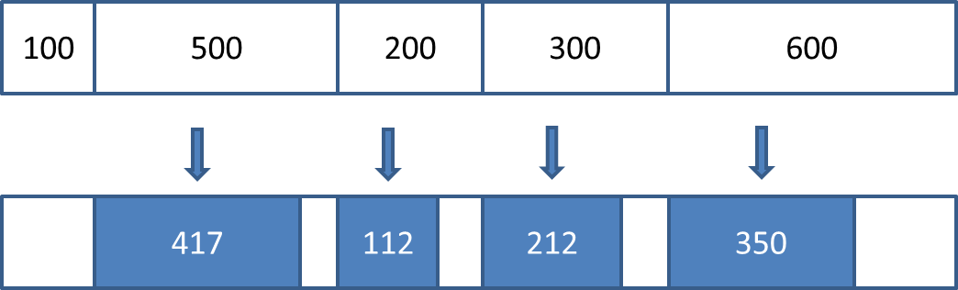

From the diagram above it can be concluded that no external fragmentation took place even though a block of free memory is available (100). All processes where assigned to a memory block. In order for external fragmentation to take place a process larger than the size of the free memory block would have to be in waiting.